# Scope:

Scope of this project is to register, maintain and retrieve records of the doctors, patients and staff in the hospital database.

# Requirements:

1.To generate a report of patient appointment history to check their eligibility for the discount.

2.To generate a patient treatment Invoice bill for requested period of time.

3.To generate a report of doctor attendance to check their eligibility for taking casual leave in a month.

4.To generate a report of doctors’ availability for booking the appointment for patient.

5.To generate a report of patient payment history.

6.To generate a report of treatment summary.

7.To book doctor appointment for a patient.

# Business Rules:

1.The patient can make appointment with only one doctor in a day.

2.A doctor can give appointment for more than one patient a day.

3.Each doctor has separate consultation fee.

4.A patient will get 30 percent discount in a doctor consultation fee from second appointment.

5.A doctor can take 2 days in a month as casual leave.

# ERD Diagram:

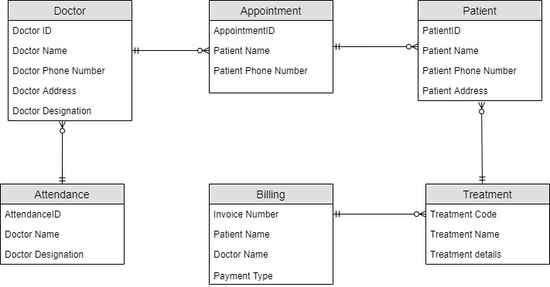

# Business Schema:

